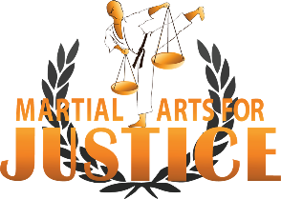
Fundraising with Canada Helps for BBBC 2019
- Check Each One Off As You Go Through

Go to https://www.canadahelps.org/en/fundraise/
Sign in Page - scroll down click Create One (Free Account no charge)
Who are you fundraising for? Add at least one charity Search Martial Arts for Justice
Fill in About Your Fundraiser
Type of fundraiser Other
Enter Title of Fundraiser BBBC 2019
Enter Start Date (date you’re starting)
Enter End Date (April 30, 2019)
Set yourself a goal amount (we recommend setting $100 for young and $200 if older, but is your choice)
Enter name of page owner Enter your First & Last Name
Make sure both boxes below are marked with a checkmark
Your Fundraising Story copy and paste description below

A future of hope requires BOLD dreams

Hello everyone and thank you for taking the time to read this update. Now more than ever I know MAJ is making a difference in our world and I see this directly in the work we are doing, and I am blessed to experience this in person. For those of you that have not been up to date on our recent work, in 2016 and 2017 we were in the development stages of how we can best empower women and girls that are vulnerable to GBV (gender-based violence) working at this time in Rwanda and Uganda. Part of the vision was always to develop training in such a way as to train trainers and be able to leverage this to make it available across the world. With what we have learned in the earlier years we executed 2 sets of training of women in 2018 in Rwanda and Uganda with significant success especially in the trauma relief aspect of our Enhanced Resilience Training. Research and writing from other leaders of trauma work back up the work we are doing as well as what we are seeing with our own eyes in the field. For more information about ERT please call or message me. Also, you can search on U Tube “healing trauma through martial arts” and our Rwanda video will come up.
Now as I write this note, significant doors have opened wide for us in Rwanda through the Rwanda Genocide Widows Association (Avega Agahozo). This is one of the largest organizations in Rwanda caring for their people. Their responsibility is caring for 19,500 widows which also includes 71,478 of their dependants most of whom are orphans. In these numbers almost 6000 are over 65 years of age and 926 are childless. These of course were all affected by the 1994 genocide. What they need is our expertise, not our handouts.
So, we have an opportunity to positively affect the lives of 100,000 people through our ERT and
The amazing thing is we are doing this by empowering them and not creating dependence which happens so often in the developing world. Enhanced Resilience Training is proven to heal trauma by reversing its affects, empowering these beautiful people to have control over their own lives and equipping them to be more resilient as THEY build their own future!
As an additional note, ERT is geared to be taught to teen girls in Canada just the same as teen girls in the developing world with the same benefits. Contact me for more info.

MAJ currently has a 5-year plan to see the ERT delivered to all 20,000 widows. We have the program and the plan and the ability to do this, but it will need your support to see it to completion. To deliver training there, it is quite cost effective per person and it will get better as we have more fully trained instructors there. Right now, our next step is to deliver 2 weeks of intense training now at the end of March early April. This will get some of their therapists up to instructor level as well as complete certification for Blaise and Zura our 2 key members there on the ground representing MAJ. The budget for this 2-week plan is about $12,000 Canadian and we are seeking your immediate support for this phase to be completed. (Contact me for more details on this phase)

The next step is to maximize our efforts through the month of April for BBBC 2019. Breaking Boards Breaking Chains will engage as many martial arts schools across Canada as possible this year to break boards while protecting and empowering people that need our help. Spread the word and sign up now to support BBBC 2019!!

Thank your again for caring to change history!

Master Dean Siminoff
President
www.martialartsforjustice.org

Summary copy & paste description below
OUR MISSION
TO PROTECT VULNERABLE PEOPLE
FROM VIOLENCE AND OPPRESSION
THROUGH THE PLATFORM OF
MARTIAL ARTS

Click Create Fundraising Page
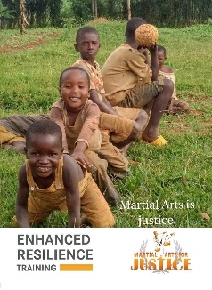
Add Images & Videos Page Save this photo to your pc then upload this image as featured Image

Media Gallery save this photo’s to your pc then upload both with Caption Martial Arts for Justice
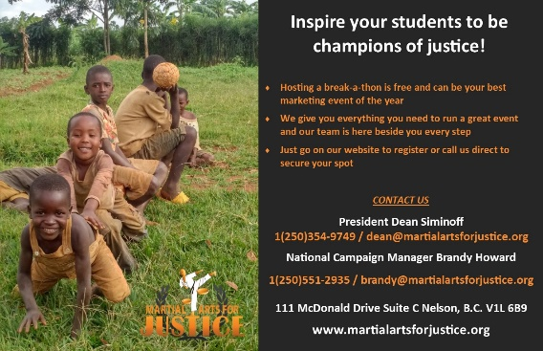
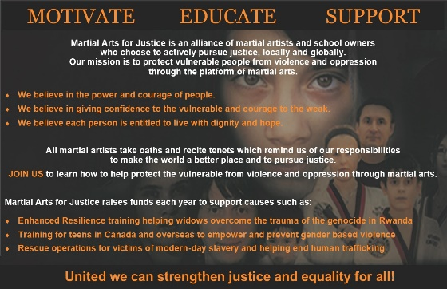

Add Video Copy & Paste this link https://www.youtube.com/watch?v=w5Hf7hlOkMc&t=99s
Add caption Founder/President Master Dean Siminoff Africa
Click Save Images & Videos
Copy and paste your page link paste here for safe keeping or somewhere you have access to it.
EX. https://www.canadahelps.org/en/pages/bbbc-2019-2/

- Click your link and view the new beginnings to your BBBC 2019 fundraising. A whole new world to fundraising. Canada Helps makes asking family, friends etc. who live all over the world a much easier process for everyone and they can feel like they are on the journey with you.

PLEASE CONTACT US DIRECTLY WITH ANY QUESTIONS OR CONCERNS
NATIONAL CAMPAIGN MANAGER
Brandy Howard
250-551-2935 or brandy@martialartsforjustice.org

Martial Arts for Justice Supporter
Leanne Wall Ebner
slebner@hotmail.com

