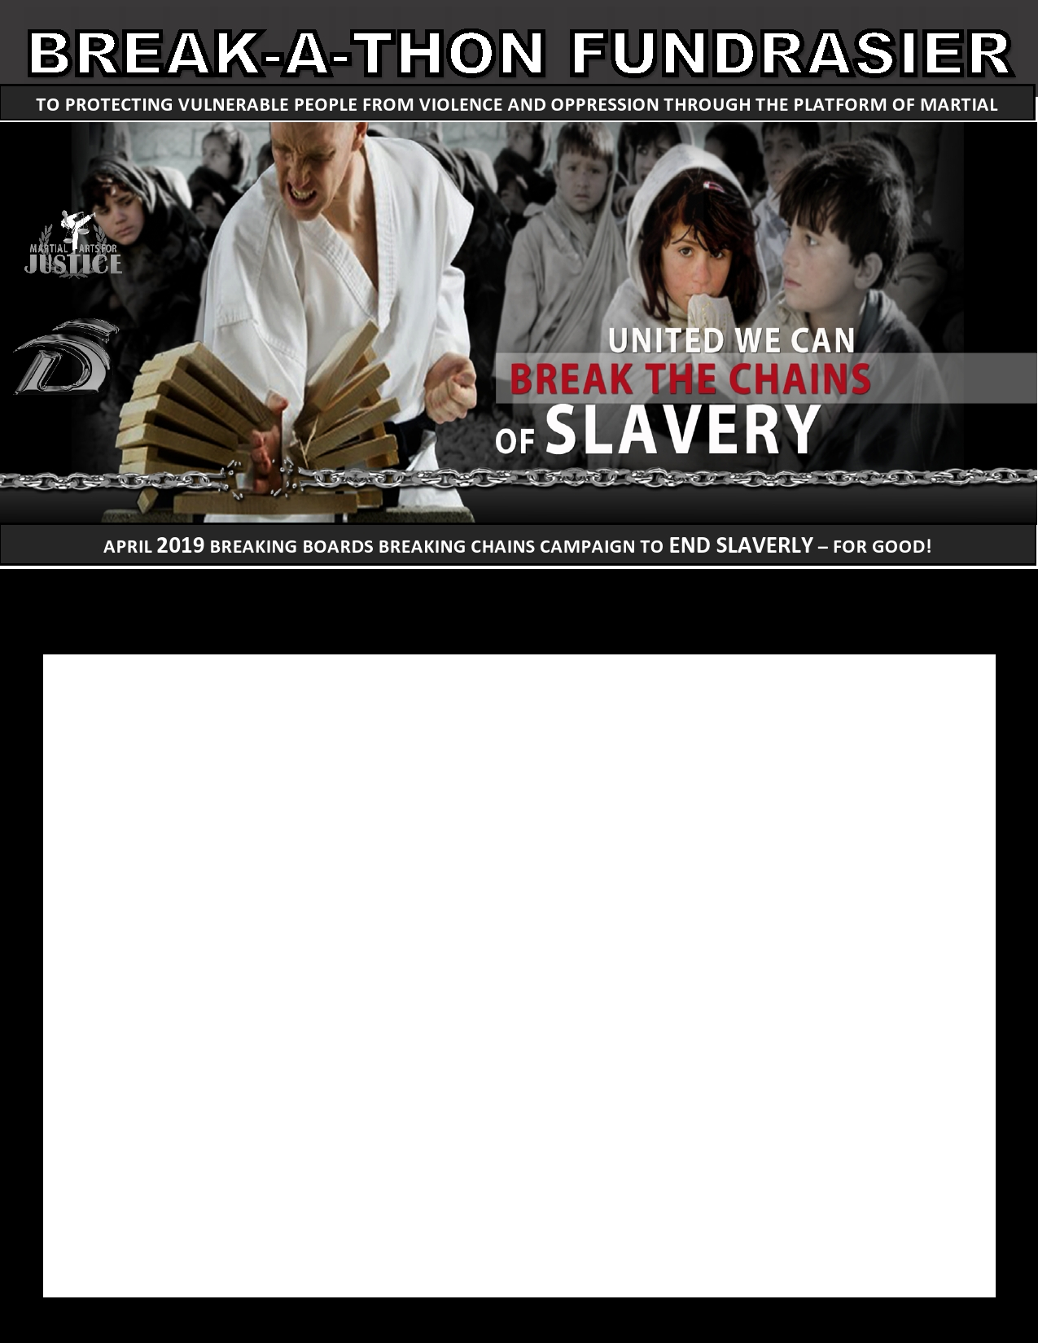
BREAKING BOARDS BREAKING CHAINS CAMPAIGN TO END SLAVERY – FOR GOOD!
INSERT LOGO HERE

Started in 2013, BBBC is MAJ’s premier fundraising event, bringing in tens of thousands of dollars a year to support the important work of Martial Arts for Justice and other great organizations like International Justice Mission (or IJM)

MAJ specializes in empowering women and girls with our Enhanced Resilience Program®.

DATE:
TIME:
LOCATION:

