

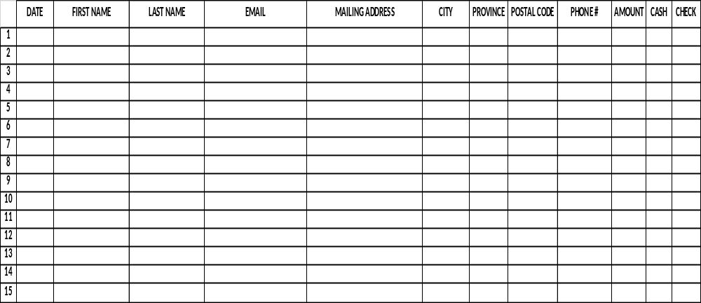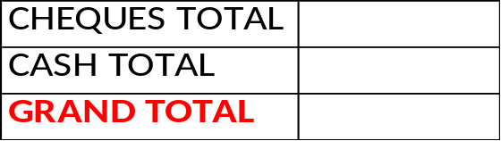
INSERT LOGO HERE
Please make all checks payable to Martial Arts for Justice. INFORMATION NEEDS TO BE LEGIABLE FOR TAX RECIEPTS TO BE ISSUED. Tax Receipts will be issued by MAJ for pledges of $15.00 or more. You may make any pledge amount you wish to contribute. If you choose you may also make pledges online at martialartsforjustice.org, you may specify a name of a student, a school or a simple dedication. Those donations made online will be issued tax receipts by Canada Helps.
BREAKING BOARDS BREAKING CHAINS
Name of fundraiser
Please remember to put your first & last name!

